Active English 2 Homework:

Homework 1: Make your plant grow and observe.

1.) | Add colored water to your seed on Tuesday and Friday. | 
2.) | Keep the seed moist and add regular water. | 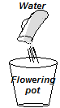
3.) | Get a flower pot and potting soil. Wait until the plant is in plumule stage.  Put some soil into the pot. Moisten the soil with water. Then make a small hole with your finger. Put the seed in the hole, with the radicle up. Sprinkle some soil on top of the seed, not covering the ridicule. | 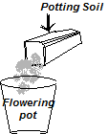
4.) | Check the progress and draw pictures and write observations  Checkout the link below to see how seeds grow.  http://www.kidzone.ws/science/seeds.htm and  http://www.youtube.com/results?search_query=plants+grow | 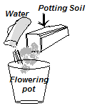

Homework 2: Take a note and draw picture and write what is happening. The first day of observations, Tuesday, is done for you as an example.

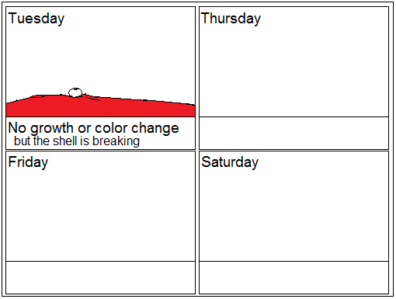

Homework 2: Finish working on your family chart homework from last week. Finish drawing and have examples for each word.

Word | Picture | Word | Picture
Social: 사회적인, 사회의  example: He is a very sociable person. |  | Household: 가족의: is all the people in a family or group who live together in a house  example: Each of us lives in a household in Busan.
Unit: 단일체, 하나,  한 사람;일단  example: |  | Member: 회원: A member of a group is one of the people, animals, or things belonging to that group  example:
Nuclear family: 핵가족: is a family unit that consists of father, mother, and children. |  | Importance: 중요[중대]성, 의의, 가치  The importance of something is its quality of being significant, valued, or necessary in a particular situation.

Word | Picture | Word | Picture
Provide : 주다, 제공하다: give it to them or make it available to them |  | Protect: 보호하다, 막다, 지키다: prevent them or it from being harmed or damaged
Wellbeing: 행복, 안녕, 복지, 복리 |  | Disability: 무능, 무력;(법률상의) 행위 무능력, 무자격: is a permanent injury, illness, or physical or mental condition that tends to restrict the way that someone can live their life.
Nurture: 양육하다, 기르다 you care for it while it is growing and developing. |  | Culture: 정신 문명, 개화: consists of activities such as the arts and philosophy, which are considered to be important for the development of civilization and of people's minds. ...

Word | Picture | Word | Picture
Knowledge: 지식, 아는 바: is information and understanding about a subject |  | property right: 재산권
Value: 가격, 값 가치: something such as a quality, attitude, or method is its importance or usefulness |  | Obligation: 의무, 구속, 책임, 책무: to do something, it is your duty to do that thing.
Attitude: 자세, 몸가짐: to something is the way that you think and feel about it, especially when this shows in the way you behave. ... |  | Generation: 동시대의 사람들, 세대: is all the people in a group or country who are of a similar age, especially when they are considered as having the same experiences or attitudes

Word | Picture | Word | Picture
Fundamental: 중요[주요]한 |  | Construct: <문장·논문 등을> 구성하다
Basis: 기초, 근거, 논거;원리, 원칙 |  | Society: 사회 (집단);

Homework 3: Work on your presentation page 1, 2, 3, and 4.

