For My Pictionary Class

Hw. 1 Work on presentation: My family

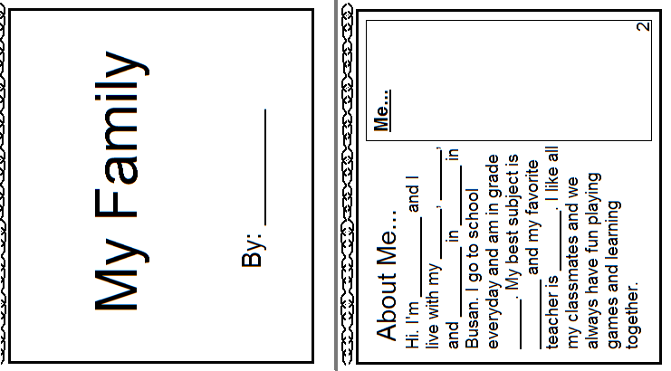

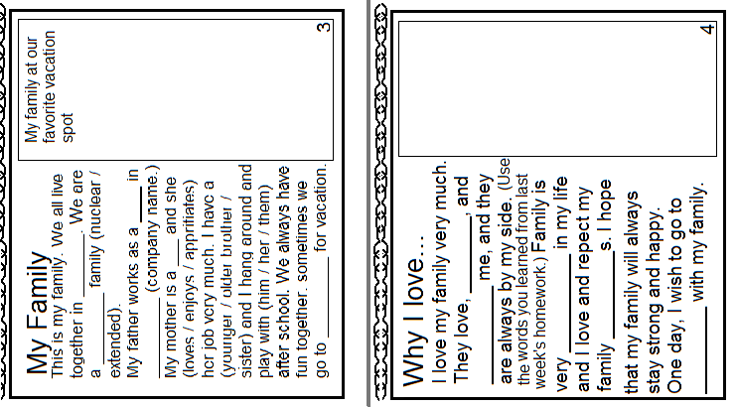

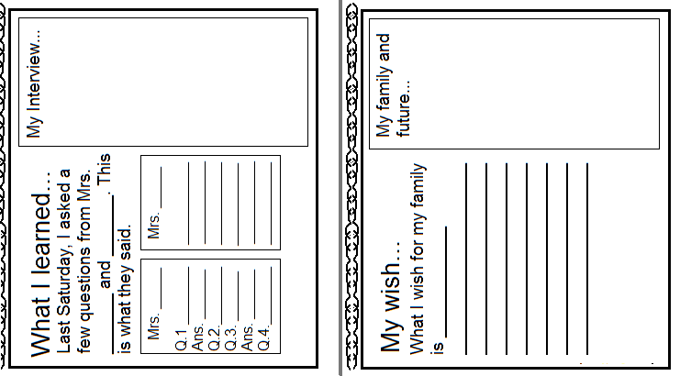

Hw. 3 Think of your family. Would they give you the same answers? Ask them and then show them your presentation up to this point.

