For Listening and writing

Hw. 1 Make a story book picture and summary in your notebooks from the stories we looked at in class.

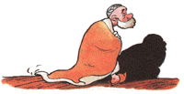
The quilt is gone, the dispute is ended
Nasreddin Hodja was awakened in the middle of the night by the cries of two quarreling men in front of his house. Hodja waited for a while but they continued to dispute with each other. Hodja couldn't sleep, wrapping his quilt tightly around his shoulders, he rushed outside to separate the men who had come to blows. But when he tried to reason with them, one of them snatched the quilt off Hodja's shoulders and then the both of men ran away. Hodja, very weary and perplexed, returned to his house.
- What was the quarrel about? wondered his wife when Hodja came in.
- It must be our quilt, replied Hodja. The quilt is gone, the dispute is ended.

Nine months journey in seven days
The Hodja's first wife had recently died. The state of single blessedness was not to Hodja's taste. So he decided to marry again. With some help from his neighbours he had no difficulty in finding a suitable widow.
Exactly seven days after the wedding the woman gave birth to a baby. Hodja immediately ran to the market, bought some paper, pencils, books and on his return put these objects beside the newborn baby. His wife seemed surprised and asked :
- But Effendi, surely the baby won't have any use for these things for a long time yet! Why the hurry?
- You are mistaken my dear, replied Hodja. A baby that arrives in seven days instead of nine months, is sure to need these things in a couple of weeks at most.

Everyone who sees the light
Hodja's wife was pregnant. One night, her labor pains started and Hodja called the neighbours and the midwife. Soon they called out from his wife's room and said,
- Hodja! You have a son! He was very happy. A few minutes later the midwife called out again,
- Hodja! You also have a girl. After a little while, she called out again, - Hodja! You have another girl! Hodja, who had been waiting in front of his wife's room, rushed into the room and bleww off the candle.
- What are you doing? asked the surprised women.
- Well! Everyone who sees the light wants to come out. What else can I do? he answered.

Hw. 2 Work on presentation: My family

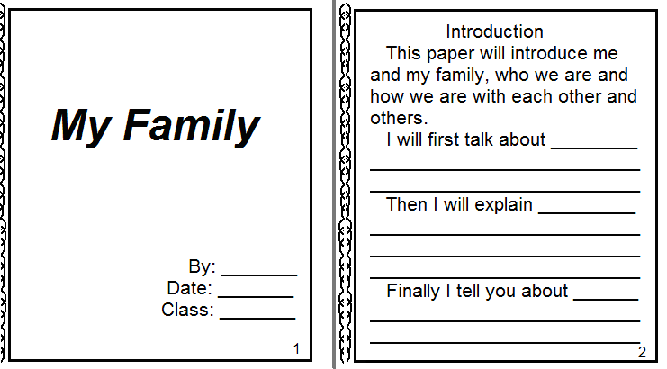

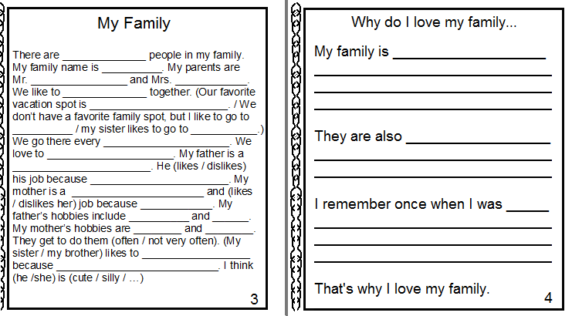

Hw. 3 Do the reading and listening exercises for the story on page 14 and 15.

